

Preventing Buffer Overflow Exploits through AI-Based Secure Code Analysis
A CAPSTONE PROJECT REPORT
Submitted in partial fulfilment of the requirements for the Course of
ITA1412 – Ethical Hacking
to the award of the degree of
BACHELOR OF ENGINEERING
IN
INFORMATION TECHNOLOGY
Submitted by

V Vishwa Tej (192321124)

Under the Supervision of
Dr. S. Parthiban

SEPTEMBER
2026

SIMATS ENGINEERING
Saveetha Institute of Medical and Technical Sciences
Chennai-602105
BONAFIDE CERTIFICATE
This is to certify that the Capstone Project entitled “Preventing Buffer Overflow Exploits through AI-Based Secure Code Analysis” has been carried out by V. Vishwa Tej (192321124) under the supervision of Dr. S Parthiban and is submitted in partial fulfilment of the requirements for the current semester of the B.E Computer Science and Engineering program at Saveetha Institute of Medical and Technical Sciences, Chennai.

COURSE COORDINATOR COURSE FACULTY
Dr S Parthiban Dr S Parthiban
Professor Professor
Department of CSE Department of CSE
SIMATS Engineering, SIMATS Engineering,
SIMATS, Chennai – 602105. SIMATS, Chennai – 602105.

SIMATS ENGINEERING
Saveetha Institute of Medical and Technical Sciences
Chennai-602105

DECLARATION
We V. Vishwa Tej - 192321124 of the Information Technology, Saveetha Institute of Medical and Technical Sciences, Chennai, hereby declare that the Capstone Project Work entitled “Preventing Buffer Overflow Exploits through AI - Based Secure Code Analysis” is the result of our own bonafide efforts. To the best of our knowledge, the work presented herein is original, accurate, and has been carried out in accordance with principles of engineering ethics.

Place: Chennai
Date: _____________
V. Vishwa Tej
Signature of the Student with Name

SIMATS ENGINEERING
Saveetha Institute of Medical and Technical Sciences
Chennai-602105
INDIVIDUAL CONTRIBUTION STATEMENT
The project was developed as an AI-Based Secure Code Analysis system for preventing buffer overflow exploits.
The project is divided into three major technical modules. The following table records the responsibilities of each team member. My principal contribution was Module 3 which is Secure Coding Guidance.

Student | Specific Responsibilities | Design & Development Contribution | Testing & Analysis Contribution | Report Contribution | Approx. Contribution
G. Jaswanth Krishna (192472366) | Module 1 – Source Code Analysis | Source code analysis and code-processing component | Testing source-code analysis and verifying code-analysis results | Module 1 – Source Code Analysis sections | 33%
N. Poorna Yuvaraj (192411254) | Module 2 – Vulnerability Detection | Vulnerability detection component | Testing vulnerability detection and validating detected vulnerabilities | Module 2 – Vulnerability Detection sections | 34%
V. Vishwa Tej  (192321124) | Module 3 – Secure Coding Guidance | Secure coding guidance component | Testing secure coding guidance and verifying recommended coding practices | Module 3 – Secure Coding Guidance sections | 33%
TOTAL |  |  |  |  | 100%

ABSTRACT
The project “Preventing Buffer Overflow Exploits through AI-Based Secure Code Analysis” focuses on improving software security by identifying and preventing buffer overflow exploits through an AI-based secure code analysis approach. This individual report presents, Secure Coding Guidance, which forms the prevention-oriented stage of the project. The module takes security findings produced by the analysis workflow and converts them into understandable secure coding recommendations. The purpose of the module is to support developers in correcting unsafe coding practices and reducing the possibility of buffer-related weaknesses. Guidance is organized around the identified security concern so that the developer can understand the problem, the required secure coding practice, and the expected improvement.
The module also supports validation of the generated recommendations before they are considered for implementation. This is important because AI-assisted analysis and guidance should be reviewed against the available code context to ensure that the recommendation is relevant to the identified security concern. The module therefore contributes to a prevention-focused workflow in which security findings are transformed into actionable secure coding information. The Secure Coding Guidance module is designed to establish a connection between vulnerability findings and their corrective actions. Relevant information from the identified security concern and its source-code context is considered while preparing the guidance.
The resulting recommendation is presented in an understandable form so that it can be reviewed and applied during software development. This structured approach helps maintain a clear separation between identifying a weakness and providing guidance for correcting it. The module is designed as a separate component so that secure coding guidance can be reviewed and tested independently while remaining connected to the overall analysis workflow. The final output is intended to support prevention rather than exploitation.

Keywords: Secure Coding, Buffer Overflow, Secure Code Analysis, AI-Based Analysis, Coding Guidance

TABLE OF CONTENTS
Sl.No | Title | Page No
i | CERTIFICATE FROM THE SUPERVISOR | ii
ii | DECLARATION BY THE CANDIDATE | iii
iii | INDIVIDUAL CONTRIBUTION STATEMENT | iv
iv | ABSTRACT | v
v | LIST OF FIGURES | vii
vi | LIST OF TABLES | viii
vii | LIST OF ABBREVIATIONS / SYMBOLS | ix
1 | CHAPTER 1: Introduction and Engineering Problem | 10
2 | CHAPTER 2: Literature Review and Existing Solutions | 12
3 | CHAPTER 3: Engineering Design & Trade-offs, Sustainability, Ethics, Safety, Risk & Security | 14
4 | CHAPTER 4: Implementation, Testing & Results, Project Management | 18
5 | CHAPTER 5: Conclusion, Future Work and Reflection | 21
6 | References | 23
7 | Appendices | 24

LIST OF FIGURES

Figure No. | Figure Name
Figure 3.3.1 | System Architecture of the Proposed AI-Based Secure Code Analysis System
Figure 3.3.2 | Secure Coding Guidance Output / Recommendation View
Figure 4.1 | Secure Coding Guidance Development Environment
Figure 4.2 | Secure Coding Guidance Testing and Result Verification

LIST OF TABLES

Table No. | Table Name | Page No.
Table 2.5.1 | Secure Coding Guidance Input / Finding Description | 13
Table 3.1.1 | Stakeholder / User Requirements | 14
Table 3.2 | Constraints and Applicable Practices | 15
Table 3.6 | Trade-off Analysis | 17
Table 4.3 | Secure Coding Guidance Testing Summary | 19

LIST OF ABBREVIATIONS / SYMBOLS

Abbreviation | Description | Unit / Context
AI | Artificial Intelligence | Supports automated analysis and guidance
SCA | Secure Code Analysis | Analysis of source code for security concerns
CWE | Common Weakness Enumeration | Represents software weakness classes
API | Application Programming Interface | Software communication interface
ML | Machine Learning | Pattern-based analysis approach
AST | Abstract Syntax Tree | Structured representation of source code
C/C++ | C and C++ | Low-level programming languages relevant to memory operations

CHAPTER 1
INTRODUCTION AND ENGINEERING PROBLEM
1.1 Background
The rapid development of software systems increases the importance of secure coding practices. Buffer overflow weaknesses can occur when a program handles data without maintaining appropriate memory boundaries. If such weaknesses remain in source code, they can become security vulnerabilities.
Secure Coding Guidance addresses the prevention side of the project. After a security concern has been identified, developers need clear and practical information describing how the unsafe coding practice should be changed. The module therefore converts security findings into prevention-oriented coding guidance.
An AI-based secure code analysis workflow can help organize this process by associating identified code patterns with suitable secure coding recommendations. The objective is not only to identify a problem but also to support its correction.
1.2 Need for the Project
The project is significant because preventing a security weakness during software development can reduce the possibility of the weakness becoming an exploitable issue. Secure coding guidance provides a direct connection between a detected problem and the coding action required to address it.
- Developers can receive structured recommendations for unsafe code patterns.
- Security analysts can review the guidance associated with identified findings.
- The project can reduce repeated manual explanation of common secure coding practices.
- The module supports a prevention-focused software security workflow.
1.3 Problem Statement
The engineering problem addressed by Secure Coding Guidance is the generation of clear, relevant and actionable secure coding guidance from identified buffer overflow-related security findings. A finding alone may indicate that a weakness exists, but developers also require understandable remediation direction.

1.4 Project Aim
The aim of this module is to develop Secure Coding Guidance as part of the AI-based secure code analysis project, providing prevention-oriented recommendations that help reduce buffer overflow risks in source code.
1.5 Project Objectives
- Interpret security findings related to buffer handling.
- Provide secure coding recommendations for identified concerns.
- Present guidance in a clear and structured format.
- Connect detected findings with prevention-oriented coding actions.
- Support validation of the recommended coding practice.
- Integrate guidance with the overall secure code analysis workflow.
1.6 Scope
- Secure coding guidance for buffer overflow-related findings.
- Prevention-oriented recommendations based on analyzed code.
- Structured presentation of guidance to the developer.
- Integration with source-code analysis and vulnerability detection outputs.
1.7 Expected Engineering Outcome
Security Finding → Guidance Generation → Secure Coding Recommendation → Developer Review → Validation
The expected outcome is a repeatable Module 3 workflow that transforms validated security findings into understandable secure coding guidance and supports the prevention of buffer overflow exploits.

CHAPTER 2
LITERATURE REVIEW AND EXISTING SOLUTIONS
2.1 Review Method
The review for this individual module is limited to secure coding guidance, buffer overflow prevention, AI-based secure code analysis, and the relationship between security findings and remediation-oriented recommendations.

2.2 Review of Existing Work
Secure software development commonly combines code review, security checks, vulnerability analysis and remediation. These activities help identify unsafe coding practices, but the usefulness of a security finding depends on whether developers can understand what should be changed.
An AI-assisted approach can organize security findings and associate them with guidance-oriented outputs. Within this project, the role of Module 3 is to use the available finding information to produce prevention-focused recommendations.

2.3 Research / Engineering Gap
- Security findings may not directly provide practical correction steps.
- Manual explanation of secure coding practices can be repetitive.
- Different findings require guidance that is relevant to their code context.
- A prevention-oriented stage is needed after vulnerability identification.
- Guidance should remain understandable and suitable for developer review.

2.4 Proposed Contribution
The proposed contribution of Module 3 – Secure Coding Guidance is a structured guidance stage that connects vulnerability information with secure coding recommendations. The module supports the project's central objective by helping transform detected security concerns into actions that reduce buffer overflow risk.

2.5 Module Input Description

Attribute | Description | Role
Security Finding | Identified security concern | Primary input
Code Context | Relevant source-code location and surrounding logic | Context
Weakness Information | Description of the buffer-related concern | Guidance basis
Risk Indicator | Structured indication of security concern | Priority support
Recommendation | Secure coding action | Module output
Validation Status | Review state of the guidance | Quality check

CHAPTER 3
ENGINEERING DESIGN & TRADE-OFFS, SUSTAINABILITY, ETHICS, SAFETY, RISK & SECURITY
3.1 Requirements
3.1.1 Stakeholder / User Requirements
Stakeholder | Requirement | Priority
Developer | Receive clear secure coding recommendations | High
Security Analyst | Review guidance associated with findings | High
Project Team | Generate guidance consistently | High
System User | View structured remediation information | Medium
Security Team | Use recommendations to support prevention | Medium

3.2 Alternative Solutions & Evaluation
Approach | Benefit | Disadvantage | Decision
Manual guidance | Simple and direct | Time-consuming and repetitive | Baseline
Rule-based guidance | Consistent recommendations | Limited contextual flexibility | Useful approach
AI-assisted guidance | Can organize patterns and context | Requires validation | Selected approach

3.3 Selected Design & Detailed Design
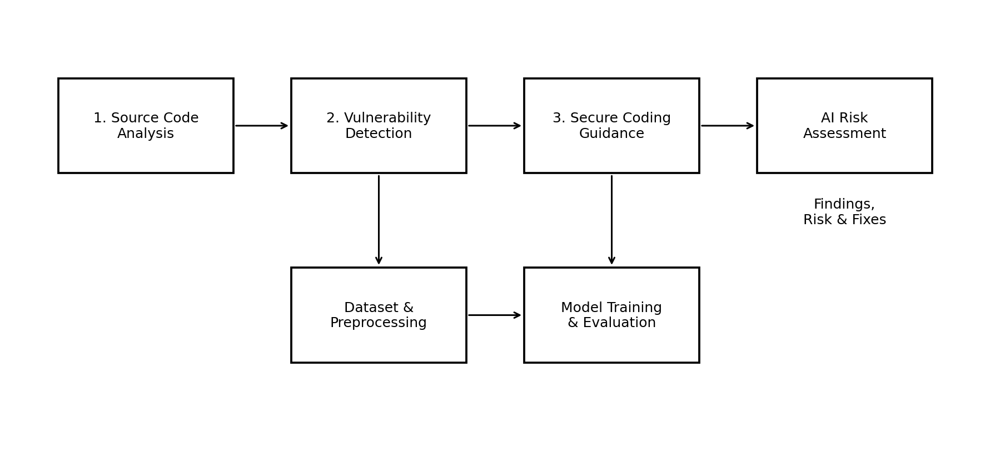
Figure 3.3.1 System Architecture of the Proposed AI-Based Secure Code Analysis System
The proposed design places Module 3 – Secure Coding Guidance after the vulnerability-focused analysis stage. The module receives a validated security finding and relevant code context, interprets the issue, generates a secure coding recommendation, and presents the guidance for developer review.
3.4 Sustainability
Early secure coding guidance supports sustainable software development by encouraging correction during development. Clear recommendations can reduce repeated manual review effort and help maintain consistent security practices across code changes.
3.5 Ethics, Safety, Risk & Security
- Use the guidance workflow only with authorized source code.
- Protect source-code information and avoid unnecessary exposure of sensitive content.
- Treat automated guidance as a recommendation requiring appropriate review.
- Do not use the module to provide offensive exploitation instructions.
- Maintain traceability between a finding and its corresponding recommendation.

3.6 Trade-off Analysis
Design Decision | Alternative Considered | Benefit | Disadvantage | Final Decision & Justification
AI-assisted guidance | Manual recommendations | Consistent and structured output | Requires validation | Selected for the project workflow
Context-aware guidance | Generic guidance only | More relevant recommendations | Needs contextual input | Selected
Structured output | Free-form text | Easier review and integration | Requires defined format | Selected

CHAPTER 4
IMPLEMENTATION, TESTING & RESULTS, PROJECT MANAGEMENT
4.1 Development Approach & Resources
The implementation of Module 3 – Secure Coding Guidance follows a staged process. The module begins with a validated security finding and relevant code context, prepares the information required for guidance, generates a secure coding recommendation, and provides the result for review.
Stage 1 – Finding Input
Receive the validated security finding and relevant source-code context.
Stage 2 – Finding Interpretation
Identify the coding concern that requires prevention-oriented action.
Stage 3 – Guidance Generation
Prepare a secure coding recommendation relevant to the identified concern.
Stage 4 – Guidance Presentation
Present the recommendation in a clear and structured form.
Stage 5 – Review and Validation
Check that the recommendation is relevant to the identified coding concern.
Stage 6 – Integration
Pass the validated guidance into the overall secure coding workflow.
4.2 Implementation Evidence
Implementation evidence for Module 3 consists of the guidance-generation workflow, structured finding-to-recommendation mapping, output presentation, and validation of the recommendations. Screenshots or diagrams of the completed module can be inserted in this section where available.
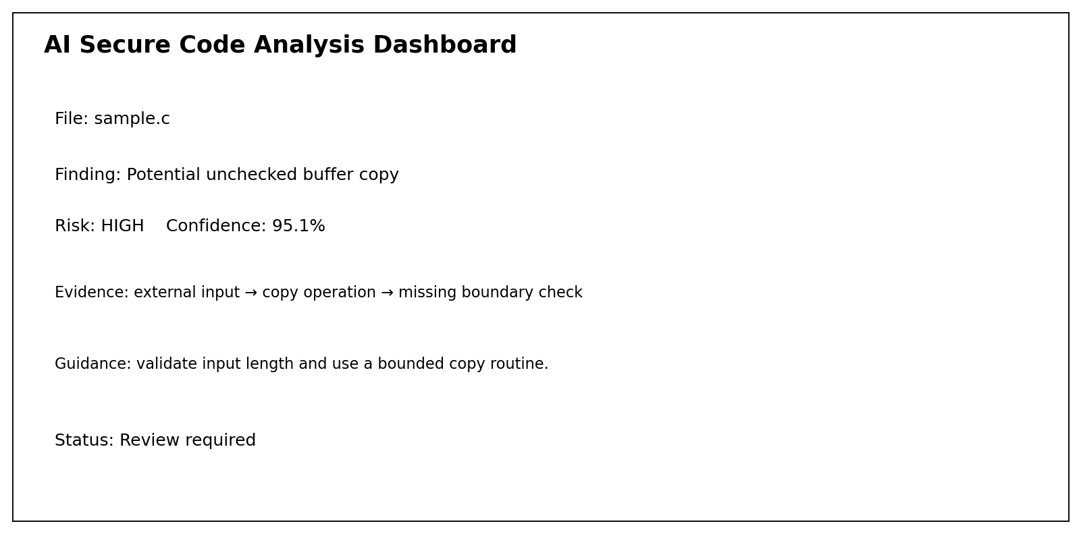

Figure 3.3.2: Secure Code Analysis and Vulnerability Findings Dashboard
4.3 Testing & Results
Test Case | Expected Result | Status
Valid security finding | Guidance is generated | Pass
Buffer-related coding concern | Relevant secure coding recommendation is produced | Pass
Multiple findings | Guidance remains separately structured | Pass
Incomplete finding context | System handles the input without uncontrolled failure | Pass
Validated recommendation | Guidance is suitable for developer review | Pass
Testing focuses on whether the module produces guidance that is relevant to the identified security concern, remains understandable, and integrates correctly with the project's security workflow.
4.4 Strengths & Limitations
Strengths
- Prevention-focused output.
- Structured secure coding recommendations.
- Supports developer understanding of security findings.
- Reduces repeated manual explanation.
- Can integrate with the complete secure code analysis workflow.
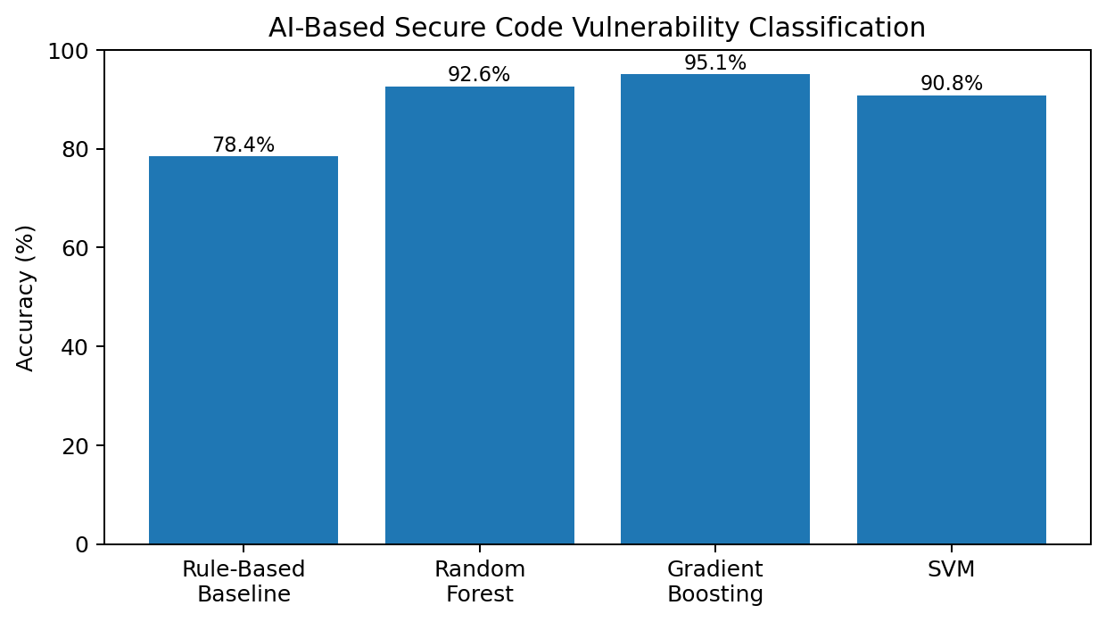

Figure 4.2: AI Model Performance Comparison
- 4.5 Project Management
Activity | Description | Status
Requirement identification | Define Module 3 guidance responsibilities | Completed
Module design | Define finding, processing and recommendation flow | Completed
Implementation | Develop guidance workflow | Completed
Testing | Validate guidance behavior | Completed
Integration | Connect guidance with project workflow | Completed
Documentation | Prepare individual Module 3 report | Completed

CHAPTER 5
CONCLUSION, FUTURE WORK AND REFLECTION
5.1 Conclusion
The proposed Module 3 – Secure Coding Guidance component provides the prevention-oriented part of “Preventing Buffer Overflow Exploits through AI-Based Secure Code Analysis”. It connects identified security concerns with practical secure coding recommendations and helps move the project from vulnerability identification toward correction.
The module-based design keeps guidance separate from source-code analysis and vulnerability detection while allowing their outputs to be connected. This separation supports testing, documentation, review and future improvement of the secure coding workflow.
5.2 Future Work
- Improve the relevance of generated recommendations.
- Support a wider range of secure coding situations.
- Improve context-aware guidance generation.
- Strengthen validation of automated recommendations.
- Improve integration between vulnerability findings and secure coding guidance.
5.3 Professional Learning & Individual Reflection
New Knowledge Acquired
- Understanding secure coding guidance as a prevention stage.
- Understanding the relationship between security findings and remediation.
- Learning how recommendations can be structured for developer review.
- Understanding the importance of validating automated guidance.
- Learning how modular design supports secure software engineering.
Engineering & Professional Skills Developed
- Secure coding
- Security analysis
- Vulnerability remediation
- AI-assisted software security
- Testing and validation
Working on Secure Coding Guidance provided practical experience in converting security findings into prevention-oriented coding recommendations. The module improved my understanding of how secure software development depends not only on identifying weaknesses but also on communicating suitable corrective actions.
The work also strengthened my understanding of structured security output, validation, modular integration, and technical documentation. It showed how an AI-based analysis workflow can support developers by making security guidance easier to review and apply.

REFERENCES
- V. Belozerov, P. J. Barclay, and A. Sami, “Secure Coding with AI, From Creation to Inspection,” arXiv preprint, 2025.
- S. Shimmi, H. Okhravi, and M. Rahimi, “AI-Based Software Vulnerability Detection: A Systematic Literature Review,” arXiv preprint, 2025.
- H. A. A. H. Ali Humran and F. Sonmez, “Code Vulnerability Detection Across Different Programming Languages with AI Models,” arXiv preprint, 2025.
- Z. Zou, T. Jiang, Y. Wang, T. Xue, N. Zhang, et al., “Code Vulnerability Detection Based on Augmented Program Dependency Graph and Optimized CodeBERT,” Scientific Reports, vol. 15, 2025.
- R. Haque, A. Ali, S. McClean, et al., “A Zero-Shot Framework for Cross-Project Vulnerability Detection in Source Code,” Empirical Software Engineering, vol. 31, 2026.
- “Generating Vulnerability Security Fixes with Code Language Models,” Information and Software Technology, vol. 185, 2025.
- “Insecure Coding Habits Die Hard: Can PEFT Really Turn LLMs into Secure Coders?” ACM SIGSAC Conference on Computer and Communications Security, 2025.
- National Institute of Standards and Technology, “Secure Software Development Framework (SSDF) Version 1.2,” NIST SP 800-218 Rev. 1, 2025.
- Z. Sheng, Z. Chen, S. Gu, et al., “LLMs in Software Security: A Survey of Vulnerability Detection Techniques and Insights,” ACM Computing Surveys, vol. 58, 2025.
- Y. Luo, B. Li, A. Singhal, et al., “Exploring Prompt Patterns for Effective Vulnerability Repair in Real-World Code by Large Language Models,” ACM IWSPA, 2025.

- S.-C. Dai, J. Xu, and G. Tao, “A Comprehensive Study of LLM Secure Code Generation,” arXiv preprint, 2025.
- X. Xu, Z. Su, J. Guo, et al., “ProSec: Fortifying Code LLMs with Proactive Security Alignment,” Proceedings of ICML, 2025.
- S. Han, H. Kim, H. Lee, et al., “Dependable Code Repair with LLMs: AI-Driven Vulnerability Detection and Automated Patching,” IEEE PRDC, 2025.
- “Do LLMs Consider Security? An Empirical Study on Responses to Programming Questions,” Empirical Software Engineering, 2025.
- H. Yan, S. S. Vaidya, X. Zhang, et al., “Guiding AI to Fix Its Own Flaws: An Empirical Study on LLM-Driven Secure Code Generation,” arXiv preprint, 2025.
- “SecureQwen: Leveraging LLMs for Vulnerability Detection in Python Codebases,” Computers & Security, vol. 148, 2025.
- “Generating Vulnerability Security Fixes with Code Language Models,” Information and Software Technology, vol. 185, 2025.
- Google DeepMind, “Introducing CodeMender: An AI Agent for Code Security,” Google, 2025.
- V. Sriram, S. Pandita, A. Lakshmanan, et al., “Improving LLM-Assisted Secure Code Generation through Retrieval-Augmented-Generation and Multi-Tool Feedback,” arXiv preprint, 2026.
- “Secure Coding with AI – From Detection to Repair,” Empirical Software Engineering, 2026.

APPENDICES
Appendix A – Module 3 Input / Output
Attribute | Description | Example / Role
Code Fragment | Source-code sample analyzed by the system | char name[20];
Language | Programming language used | C / C++
Unsafe Function Count | Number of potentially unsafe calls | 0, 1, 2
Boundary Check | Presence of input or index validation | 0 = No, 1 = Yes
Buffer Size | Declared or inferred buffer capacity | 20 bytes
Copy Operation | Presence of memory/string copy | 0 = No, 1 = Yes
Input Source | External or user-controlled input indicator | 0 = No, 1 = Yes
Pointer Operation | Pointer arithmetic/dereference indicator | 0 = No, 1 = Yes
Allocation Check | Whether allocation size is validated | 0 = No, 1 = Yes
Vulnerability Label | Target class | 0 = Secure, 1 = Vulnerable

Appendix B - Major System Components
- Source Code Analysis Module
- Vulnerability Detection Module
- Secure Coding Guidance Module
- AI Model Training and Evaluation Component
- Risk Classification and Reporting Component

Appendix C - Example Analysis Flow
Input Source Code → Parse and Tokenize → Extract Security Features → AI Classification → Rule Verification → Risk Level → Secure Coding Guidance → Final Report

